UWSOD Protocol – 6/30/2020

This is based on current information from the state and University of Washington. Because restarting clinical practice will take place incrementally, some dates may be adjusted. All faculty, staff, and students must complete a daily self-screening and attestation related to COVID-19 symptoms.

UW School of Dentistry Main Campus Protocol

- Patients needing procedures with a low risk of aerosol generation:¹
  - Contact the patient via telephone 24 to 48 hours before the appointment and administer the screening questions (below). This may be done by students or staff. This screening is not a billable teledentistry appointment.
  - Appoint the patient.²
  - Repeat the screening at the time of the appointment.^{3,4}
  - Provide treatment following the PPE chart below.
- Patients needing procedures with a moderate to high risk of aerosol generation (most dental hygiene procedures, intraoral use of a hand piece or ultrasonic device, surgical extractions):
  - Contact the patient via telephone 24 to 48 hours before the appointment and administer the screening questions (below). This may be done by students or staff. This screening is not a billable teledentistry appointment.
    - If any screening item is positive, delay the appointment for 14 days while the patient self-quarantines. Medically manage any dental issues. Advise patient to call their PCP for appropriate care. Meet with the patient periodically via telephone to assess their condition/status. These periodic checks should be done by a faculty member or resident. These are not billable teledentistry appointments.
    - If all questions are negative, order a COVID-19 test following the procedure below.
  - Appoint the patient (ideally within 24 hours of the test result, but procedures may be completed within 72 hours of a negative COVID-19 test).⁵ There may be exceptions to the 72-hour rule, based upon specific patient circumstances and professional judgment of attending faculty. This analysis must consider patient risk factors including social habits, recent participation in community events, travel within the past 14 days, working in a setting that requires close contact with other employees or clients, interaction with people in a group of 5 or more, living with someone who has engaged in these things or has had COVID-19 symptoms, and other risk factors.
  - Administer the screening questions at the time of the appointment.^{3,4}
  - Follow the PPE chart below.
  - For patients needing multiple aerosol-generating procedures, attempt to triage care so that multiple appointments can be accomplished within 72 hours of the COVID-19 test. Patients must be instructed to remain at home and observe social distancing and risk reduction behaviors during the 72-hour period. Depending upon professional judgment by faculty, this time can be extended for specific patients where there is a high level of confidence that the patient is engaged in effective personal risk reduction behaviors (social distancing, frequent hand washing, avoidance of gathering).⁵
  - Provide aerosol-generating care in operatories that have extended walls and air purification units in place.⁶
  - Provide care using high-volume suction.
  - Use well-adapted rubber dams whenever possible. Disinfect the operative area with hydrogen peroxide or povidone iodine after placement of the rubber dam.
- The ATC clinic will prioritize high-risk patients who require extra protections, (e.g., those who are older and/or with comorbidities).
NOTES

            - Radiographs, exams, oral hygiene instruction, fluoride application, placement of interim restoration without the use of a hand piece, simple extractions, appliance adjustments, impressions, biopsy, administration of local anesthetic, bite records, try-ins, deliveries.
            - All visitors to the School of Dentistry are prohibited until further notice. Patients may be accompanied only by support people who are absolutely essential to the completion of their visit. All others are not permitted to enter the building.
Until further notice, all pre-doc clinical activity will be assigned to clinical locations based upon availability of space and appropriate precautions. The D-3 clinic will be used whenever possible, according to the schematic below. This allows patients to enter through the main lobby and come directly to the clinic without using elevators or stairwells.
The ATC clinic will be prioritized for high-risk patients (those who are older and with comorbidities).
            - A negative symptom screening and a normal temperature do not rule out COVID-19 infection, and individuals incubating COVID-19 infection are typically infectious for 48 to 72 hours before the onset of symptoms. Therefore, screening for COVID-19 through questionnaires and body temperature is helpful but not definitive.
            - The most recent estimate of SC-2 positivity in asymptomatic patients scheduled for the OR at UWMC was 6 positive tests out of >1000 patients, and the false negative rate for the coronavirus test in the laboratory is 4.1%.
Risk of exposure to SC-2 is <1.1% (upper limit of the 95% CI) x 4.1% = <4.5 exposures to SC-2 per 10,000 patient contacts with asymptomatic test negative patients.
Using a surgical mask with an estimated filtering effectiveness of >95% (leakage <5%), the risk of exposure is 1.1% x 4.1% x <5% = <2.3 SC-2 exposures per 100,000 patient contacts. (Dr. Thomas Dodson, 5/12/2020)
            - Examples include but are not limited to:
              - An AGP is performed for a patient who tests COVID-19 negative. Subsequent AGPs are required, all performed with use of a well-adapted rubber dam with the operative site disinfected prior to use of a hand piece. The patient consistently screens negative for symptoms. High-volume evacuation is used at the source.
              - Permanent cementation of a crown/bridge two weeks after a negative COVID-19 test for a patient who screens negative for symptoms.
              - Performing radiographs or impressions for a patient with a sensitive gag reflex who screens negative for symptoms. An N-95 or KN-95 mask and face shield will be used.
              - The only aerosol generated will be from an air/water syringe, and an assistant using high-volume evacuation at the source will be present. The patient screens negative for symptoms, and Level III or higher masks and face shields will be used.
            - The main campus clinics will have plexiglass wall extenders installed to reduce the horizontal spread of aerosols. They will also employ portable air filtration systems with HEPA filters of appropriate size, UV-C light, and titanium dioxide filters. These clinic modifications will be implemented by UW Facilities and will be completed over the next few weeks.

Screening Questions
.
1. FEVER OR OTHER SYMPTOMS
Are you feeling unwell with symptoms (not attributable to other causes) such as?
Yes □ No □ | Fever of 100.4 or more or chills
Yes □ No □ | Cough
Yes □ No □ | Shortness of breath, difficulty breathing
Yes □ No □ | Flu-like symptoms
Yes □ No □ | Muscle pain or fatigue
Yes □ No □ | Vomiting, diarrhea, stomach pain
Yes □ No □ | Runny nose, sore throat
Yes □ No □ | Red or painful eyes; itching or scratchy eyes
Yes □ No □ | New and abrupt sensory loss of taste or smell

Please check □ YES to ANY of the above □ NO to ALL of the above

2. CONTACT HISTORY
In the past two weeks, have you had close contact with someone diagnosed with COVID-19? (Close contact = Living with or caring for someone who has a confirmed diagnosis, being within 6 feet of someone with COVID-19 for around 10 minutes, or if you’ve shared their utensils, kissed them, or been coughed or sneezed on by a person with confirmed COVID-19.)

In the past two weeks, have you had 10 minutes or more close contact with large groups of people (15 or more)?
Please check □ YES □ NO
If a patient responds “yes” to any symptom question the day before the appointment:
- Advise them to stay home and contact their PCP.
- They must be free of fever for three full days.
- They must wait at least 10 days from the onset of symptoms before being appointed.
If a patient responds “yes” to any contact history question the day before the appointment:
- Advise them to self-quarantine for 14 days while monitoring for symptoms every day.
- Advise them to contact their PCP if they develop symptoms.

If a patient responds “yes” to any symptom question on the day of the appointment:
1) Take the patient’s temperature, if not already taken.
- Have the patient don a surgical mask.
- Summon a faculty member to:
  - decide if/how to medically address the patient’s dental symptoms;
  - arrange for monitoring and/or testing;
  - arrange for dental follow-up; and
  - inform infection prevention and control services, local and state public health authorities, and other health care facility staff as appropriate about the presence of a person who requires investigation for COVID-19.

Patient (Adult) | • | • | • |  | • | • | See below
Patient (Pediatric or Special Population) | • | • |  | • | • | • | See below
Procedure Type | Non-patient care | Non-AGP  Extraoral or limited intraoral procedure | Non-AGP prolonged intraoral procedure | Non-AGP  prolonged Intraoral procedure | Aerosolizing procedures | Aerosolizing procedures | Any procedure
Example of Activity | Reception  Administrative work  Office work  Walking in halls  Sitting in cafeteria | Patient temperature  Cleaning operatories  Exam  Radiographs  Intraoral photos  Topical fluoride | Simple extraction  Sedative filling  Suture removal  Re-cement crown | Simple extraction  Sedative filling  Suture removal  Re-cement crown | Surgical extraction  Endodontic Tx  I&D  Repair fractured tooth  Adjust prosthesis | Surgical extraction  Endodontic Tx  I&D  Repair fractured tooth  Adjust prosthesis | See below
COVID Test Status | Not required | Not required, negative for all screening criteria | Not required, negative for all screening criteria | Not required, negative for all screening criteria | Required, Results negative within 72 hrs* | Test unable to be performed due to urgency or other reason | Results obtained, AND presents with symptoms
Overall Risk of Exposure | Low | Low | Medium | High | Low | High | High
Mask Level** | Level I: Extended Use Masking Policy (1 per day) | Level I-III  Change between patients | Level I-III  Change between patients | N95, KN95  Multi-use*** | Level I-III  Change between patients | N95, KN95  Multi-use*** | N95, KN95  Multi-use***
Face Shield | Not Required | Required | Required | Required | Required | Required | Required
Gown**** | Not Required | Required | Required | Required | Required | Required | Required
Gloves | Not Required | Required | Required | Required | Required | Required | Required
Surgical Cap/Bouffant | Not Required | Not Required | Required | Required | Not Required | Required | Required
Other |  |  |  |  |  | Requires sign-off by clinic director before proceeding | Attending faculty enters room to speak with patient and determine next steps  Cleaning operatory afterward

*Order and wait for COVID-19 test results before completing any aerosolizing procedure or non-aerosolizing procedures that involve prolonged intraoral exposure. A negative COVID-19 test is accepted by UWMC for up to 72 hours prior to an aerosol-generating procedure. UWSOD strongly recommends a shorter window of 24-36 hours. Accepting a negative test result of more than 36 hours must be based upon clinician risk-assessment for the specific patient and clinical judgment.

**Level 1: Low barrier. Designed for procedures with a low amount of fluid, blood, aerosol exposure, or spray. Particle filtration efficiency @ 0.1 micron is >95%. (A COVID-19 virus particle is spherical with an approximate diameter of 0.125 microns.) Resistance to penetration by fluid under pressure is 80 mm Hg.
Level 2: Moderate barrier. Suitable for procedures with a light to moderate amount of blood, fluid, aerosols, or spray. Particle filtration efficiency @ 0.1 micron is >98%. (A COVID-19 virus particle is spherical with an approximate diameter of 0.125 microns.) Resistance to penetration by fluid under pressure is 120 mm Hg.
Level 3: High barrier. Ideal for procedures with a moderate to high amount of blood, fluid, aerosols, or spray. Particle filtration efficiency @ 0.1 micron is >98%. (A COVID-19 virus particle is spherical with an approximate diameter of 0.125 microns.) Resistance to penetration by fluid under pressure is 160 mm Hg.

***When using an N-95 mask for multiple patients, place a regular surgical mask over it. At the conclusion of a procedure, dispose of the regular surgical mask and disinfect the N-95 mask prior to reuse. N-95 masks may be used up to five times unless soiled.

**** Gowns may be worn between patients in some instances including:
  - Faculty performing student procedure checks where gowns do not get visibly soiled
  - Performing non-aerosolizing procedures
- Student gowns should be changed between morning & afternoon sessions
- Gowns should be discarded/laundered after procedures when visibly soiled

Faculty, staff, and students must use a regular mask in non-clinical and common areas or when working in proximity to others.

- Each health care worker must wear a mask outside of direct patient care and will be issued a single-procedure mask at the beginning of their shift. These masks will be worn for the duration of the shift.
- A mask may be worn continuously unless it becomes wet or soiled.
- When interacting with patients on droplet/contact precautions, a face shield must be worn to protect your eyes and the mask.
- Masks should always cover the nose and chin when worn.
- Hand hygiene must be completed before and after touching your mask.
- Your mask should be stored in a clean and dry place when eating or drinking.
- There will be no eating or drinking in patient care areas or within 6 feet of another person.

COVID Testing Protocol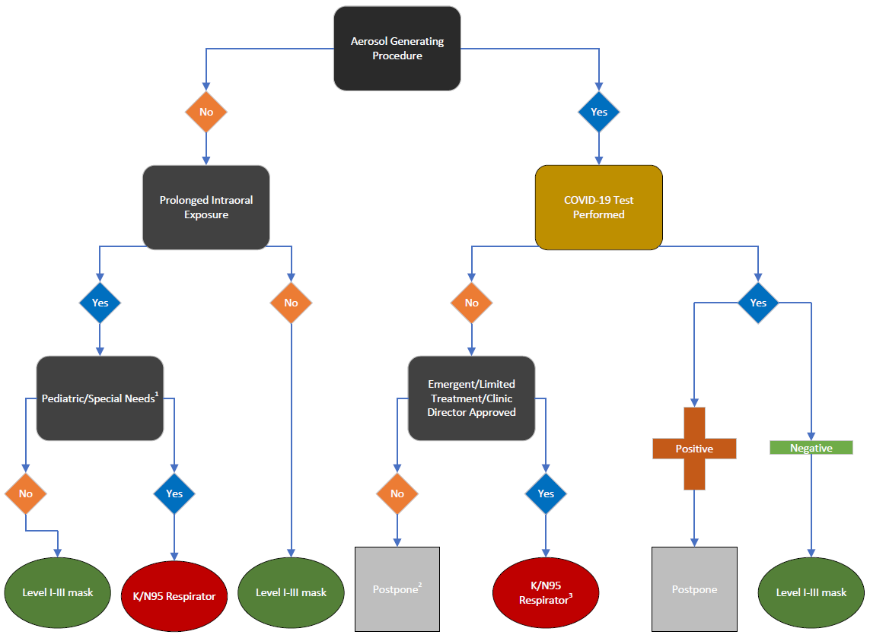
1) For example, a patient who may have difficulty cooperating with planned procedures.
2) Counsel patient based on symptoms and reschedule at least 2 weeks later.
3) Use isolated room for non-AGP; use airborne infection isolation room for AGP.
Note: This flow chart is specific for COVID-19 testing. However, the same decision process should be used for other serious contagious agents.

UW Resources:

https://www.uwmedicine.org/coronavirus
https://www.washington.edu/coronavirus/faq/

